URGENT message from Rosliston Parish Council Re : The Oaklands Farm Solar Limited proposal

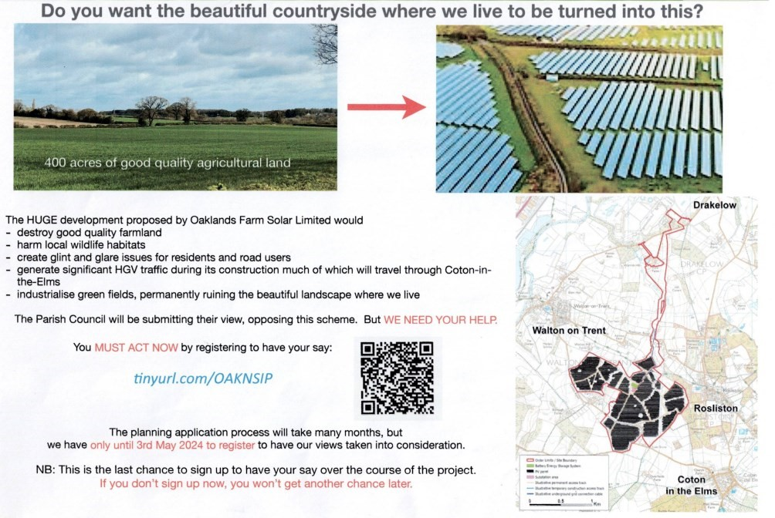

and Rosliston

https://national

-

infrastructure

-

consenting.planninginspectorate.gov.uk/projects/EN010122